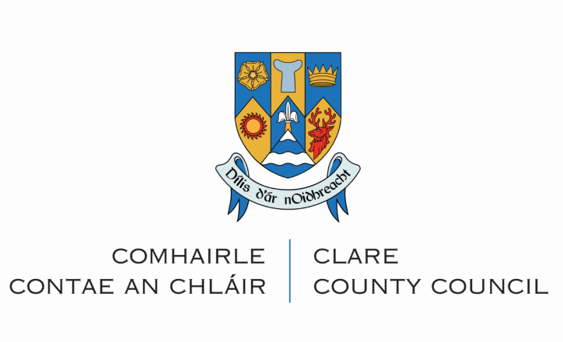

Streetscape Enhancement Grant Scheme 2022

Application Form

The Scheme is being funded by the Department of Rural and Community Development and is administered by Clare County Council. The focus is on supporting the upgrade and enhancement of shop-fronts and street facades of defined areas within the selected rural town/village centres. Eligible works include painting, signage replacement, shop-front improvement, scaffolding, materials, lighting and planting.

- All questions must be answered
- Please ensure you submit digital photography pre and post completed works
- Please note that all works must be completed by Friday 7th July 2023 to avail of funding
- Works must not commence prior to receipt by the Local Authority of the Grant Application and written approval from the local authority.

Please return fully completed application forms to:

Clare County Council,
Rural & Community Development
Rural Directorate,
Áras Contae an Chláir,
New Road, Ennis, Co. Clare

or email to townandvillage@clarecoco.ie

by 4:00p.m. on Friday, 23rd September 2022

Section 1: Applicant Information
Applicant Name:

Applicant Address:

Business Name:
(if a business is currently
operating from the premises)

Business Address:
(if a business is currently
operating from the premises)

Business Type:
(if relevant)
Tel. Number (1): | Tel. Number (2):
Shop-front (Tick if applicable) | Main Street Residence (Tick if applicable)
E-Mail Address:

Applicant’s Interest in Property:
(owner, tenant or other)

If an owner, tenant or other, please state the number of
years remaining on the lease:
Also attach a letter of consent from
the owner for the improvement works

Section 2: Proposed Works

Works Proposed:
Please tick:

- Green Enhancement of Entrances/Terraces with planting (Max funding €500 per building)
Details: (note 2 quotes required unless undertaking the work yourself, in which case receipts for the cost of materials only are eligible for funding)

(b) Paint and redecorate Building Façade; De-cluttering and repair of Building Facade (Max funding €3,500 per building)
Details: (note 2 quotes required unless undertaking the work yourself, in which case receipts for the cost of materials only are eligible for funding)

(c) Other Facade Improvement Works as below (Max funding €4,000 per building)
Details: (note 2 quotes required unless undertaking the work yourself, in which case receipts for the cost of materials only are eligible for funding)
Please select from below:
- Illumination and lighting of architectural features
- Replacement of Signage with traditional wooden fascia with wooden/hand painted lettering OR contemporary design
- Canopies/Awnings complementary to the materials of the shop-front and building (including Street Furniture)

Note: Please provide exact details of works proposed including a copy of any relevant plans, designs, and specifications for proposed works (i.e., if planning permission or Section 57 Certification or Exemption Certificate is required).

All applications must include colour photographs of the existing property and colour photographs must be submitted of completed works before funds can be drawn down.

Is planning permission required
for any of the proposed works: Yes ☑ No ☑

Please note that it is the applicant’s responsibility to ensure the requirements for planning permission have been met. Such requirements are not dealt with through the application process for this Scheme.

Total Value of Proposed Works: | €:
Value of Grant Assistance Sought: (Max Grant of €8,000 per building)  Note: Grant funding will be provided at following rates  - 70% for individual premises – match funding of 30% required.  - 80% for Joint Applications (group of 3 or more adjacent buildings – match funding of 20% required | €:
Proposed Start Date of Works:
Proposed Completion Date of Works:
Please note that all works must be completed by 7th July 2023 to avail of funding.

Section 3: Declaration
I/We declare that I/We have read the Guidance Notes and understand the conditions therein. All information given within this application and any supporting material is correct to the best of my/our knowledge. I/We agree to Clare County Council making any necessary enquiries relating to the assessment of this application for grant assistance.
Signature of applicant: | Date:

CHECKLIST

• Fully completed application form (all answers filled in)

• Letter of Consent from Property Owner (if property is rented)

• Copy of relevant detail for proposed works. Note that planning permission may be

required for some works and it is the applicant’s responsibility to ensure the

requirements for planning permission have been met. Such requirements will not

be dealt with through the application process for this scheme.

• Colour photographs of the existing property.

The Council reserves the right to publish photographs of improved shopfronts and building facades in promotional material associated with the scheme and its purpose.

The Scheme may be the subject of review and amendment at any time by the Council.

THIS SECTION OF FORM IS FOR OFFICE USE ONLY
Office Use Only: | Date Application Received:
Application Complete:  Yes  No | Photograph Included:  Yes  No
F/I Requested:  Yes  No | F/I Received:  Yes  No
Decision to Grant Assistance:

Yes

No

