**Expression of Interest Form**

**Town & Village Renewal Scheme 2023**

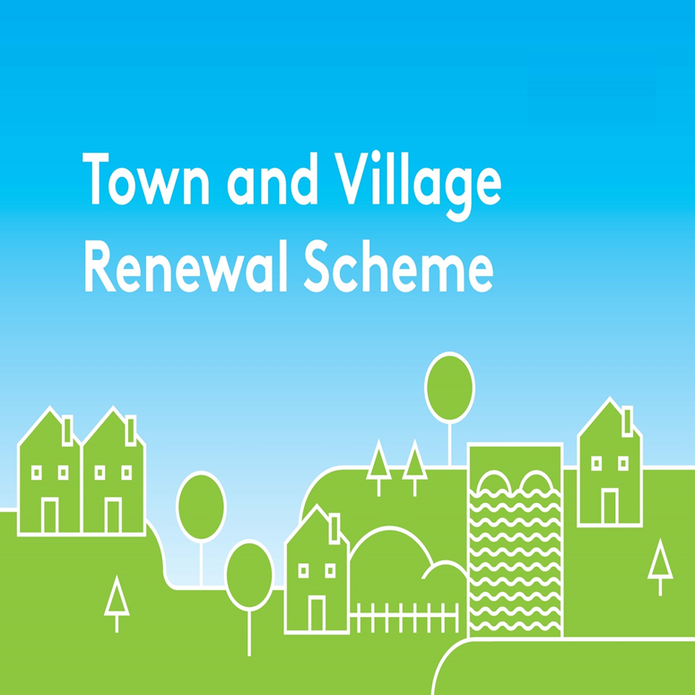

Please complete this Expression of Interest form

and return via email to [townandvillage@clarecoco.ie](mailto:townandvillage@clarecoco.ie)

**By Friday 6th October 2023**

**Town & Village Renewal Scheme 2023**

**Town/Village covered:**

**Please indicate which category of funding is being applied for:**

**Category 1 Category 2 Category 3**

**Towns/Villages with Towns/Villages with Towns/Villages with**

**Population of 5,000 Population of Population up to**

**or less 5,001-10,000 15,000**

**Amount of Funding Requested:**

**Applicant Group:**

**Applicant Contact Name:**

**Applicant Contact Address:**

**Applicant Telephone Number:**

**Applicant Mobile Number:**

**Applicant Email Address:**

1. **Has funding for this project ever been sought from other sources?**  Yes  No

**(If "YES" yes please specify from what source and if funding was provided)**

|  |
| --- |
|  |

1. **Who are the specific project stakeholders/community partners in this project?**

**(Chamber of Commerce, Community group, etc.).**

|  |
| --- |
|  |

1. **Project details: \***

**NOTE: If the project relates to the renovation or refurbishment of a community centre then the Community Centres Questionnaire must be completed.**

**If the project relates to a Hub then the Hubs Questionnaire must be completed.**

**Click on the following link for forms: https://clarecoco.ie/services/community/grants/townandvillagerenewal/**

|  |
| --- |
|  |

1. **If seeking funding of between €250,000 and €500,000, please detail the particular case for this level of funding.**

|  |
| --- |
|  |

1. **What is the objective of the proposed project and how will the intended outcomes be measured? (Please identify any metrics or benchmarks that will be applied).**

|  |
| --- |
|  |

1. **Permissions & Planning**

**(a)** Does the proposed project involve works to a building/property or lands that are not in the ownership of the Local Authority or Local Community Partner? If yes, provide details of the current owner/s.

**(b)** If the building/property is not in the ownership of the Local Authority or community group partner, has permission has been granted by the owners to carry out the proposed works? A lease must be in place at project commencement date and for a minimum of 15 years from project completion date. Is this in place?

**(c)** Are all appropriate assessments, screenings and planning permissions in place?

**DECLARATION**

1. **Timeline:**

Provide a timeline for commencement and completion of the project.

Any project that has not commenced by the end of the agreed 18 month timeframe will automatically be decommitted.

|  |  |  |
| --- | --- | --- |
| **Commencement date** | **Completion Date** | **Indicative time frame (weeks/months):** |
|  |  |  |

1. **Project Costings**

Please provide detailed breakdown of all elements of the proposed works including any administration/other fees/costs/signage:

(please add additional rows for costs as required)

|  |  |
| --- | --- |
| **Project Element** | **Estimated Cost (inclusive of VAT)** |
| **1. e.g. signage** | € |
| **2.** | € |
| **3.** | € |
| **4.** | € |
| **Local Authority Costs, (if applicable)** |  |
| **1.** | € |
| **2.** | € |
| **Total Project Cost** | € |
| **Grant Aid amount sought:**  (Max of 90% of total project costs, 95% for NW Region counties) | € |
| **Match Funding: (Min 10% of total cost, 5% for NW Region counties)**  **To be supplied by:** | € |
| **Any other relevant information:** |  |

|  |
| --- |
| **I hereby confirm that I have read and understand this document. I request that consideration be given in support of the project as outlined above.**  **Signature __________________________________________________**  **Position __________________________________________________**  **Date __________________________________________________** |