**Expression of Interest Form**

**Project Development Measure**

**Town & Village Renewal Scheme 2025**

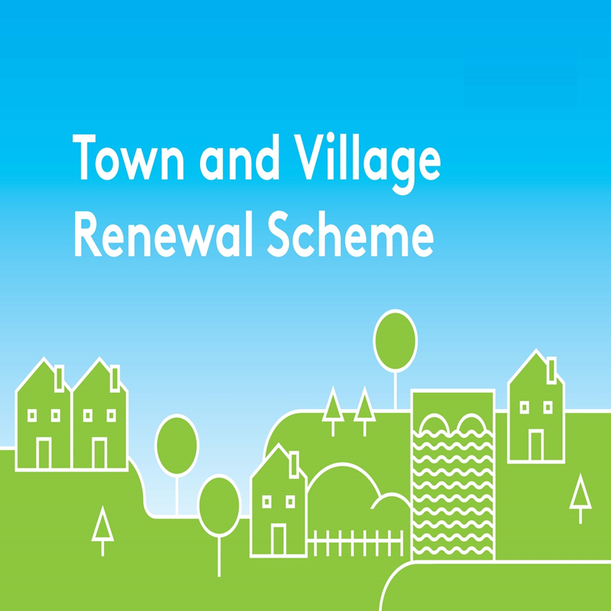

Please complete this Expression of Interest form

and return it to [townandvillage@clarecoco.ie](mailto:townandvillage@clarecoco.ie)

**By Friday 30th May 2025 at 4pm**

**Town/Village covered:**

**Please indicate which category of funding is being applied for:**

**Category 1 Category 2 Category 3**

**Towns/Villages with Towns/Villages with Towns/Villages with**

**Population of 5,000 Population of Population up to**

**or less 5,001-10,000 15,000**

**Amount of Funding Requested:**

**Applicant Group:**

**Applicant Contact Name:**

**Applicant Contact Address:**

**Applicant Telephone Number:**

**Applicant Mobile Number:**

**Applicant Email Address:**

1. **Has funding for this project ever been sought from other sources?**  Yes  No

**(If "YES" yes please specify from what source and if funding was provided)**

|  |
| --- |
|  |

1. **Who are the specific project stakeholders/community partners in this project?**

**(Chamber of Commerce, Community group, etc.).**

|  |
| --- |
|  |

1. **Have you discussed your proposal with any of the following before submitting this Expression of Interest**
2. **Rural and Community Development Officer**
3. **Town Regeneration Officer**
4. **Project details:**

|  |
| --- |
|  |

1. **What is the objective of the proposed project and how will the intended outcomes be measured? (Please identify any metrics or benchmarks that will be applied).**

|  |
| --- |
|  |

1. **In accordance with the Scheme outline projects should align with a Town Centre First Plan, County Development Plan, Local Economic and Community Plan (LECP), or other relevant strategic/statutory plans. Please outline how your proposed project aligns with a specific plan for your town or village.**

|  |
| --- |
|  |

1. **Project Costings**

Please provide a detailed breakdown of **all elements** of the proposed works including any professional fees/costs/signage etc : (please add additional rows for costs as required)

|  |  |
| --- | --- |
| **Project Element** | **Estimated Cost (inclusive of VAT)** |
| **1.** | € |
| **2.** | € |
| **3.** | € |
| **4.** | € |
| **Local Authority Costs, (if applicable)** |  |
| **1.** | € |
| **2.** | € |
| **Total Project Cost** | € |
| **Grant Aid amount sought:**  (Max of 90% of total project costs) | € |
| **Match Funding: (Min 10% of total cost)**  **To be supplied by:** | € |
| **Any other relevant information:** |  |

**DECLARATION**

|  |
| --- |
| **I hereby confirm that I have read and understand this document. I request that consideration be given in support of the project as outlined above.**  **Signature __________________________________________________**  **Position __________________________________________________**  **Date __________________________________________________** |