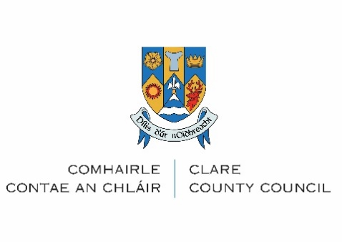
Affordable Purchase Document Checklist

You should be ready to upload the following in word, pdf or jpg/png format:

Proof of ID for each applicant – any one of the following documents:
☐ Current Valid Signed Passport
☐ Current Valid Passport Card
☐ Current Valid Public Service Card
☐ Current Valid EU/EEA Driving Licence – must contain photograph (Irish Provisional Licence accepted)
☐ Current EU National Identity Card

Proof of Present Address dated within the last 6 months for each applicant: any one of the following documents:
☐ Current utility bill (gas, electricity, landline telephone (not mobile))
☐ Bank statement/Credit Union statement
☐ Document issued by government department that shows your address
☐ Statement of Liability P21 from Revenue

Proof of Income for each applicant – acceptable forms of proof of income are:
☐ Proof of income: PAYE employees: If EMPLOYED, please provide an Employment Detail Summary (previously known as P60) which is available via www.revenue.ie/MyAccount. Please also arrange to have this salary certificate completed by your employer. Payslips are NOT acceptable evidence.
☐ Proof of income: Self-Employed: Documents for previous 2 years: Audited/Certified Accounts, Tax Balancing Statement and Tax Payment Receipt.
☐ Social Welfare Income: Please upload Statement of total benefits received from Social Welfare which can be requested via email from your local Social Welfare/Intreo office.

Evidence of Ability to Finance the Purchase:
☐ Proof of savings and deposit in the form of a current bank statement for all accounts held by all applicants on headed paper dated within the last 6 months. (If applicable, please include proof of Help-to-Buy).
☐ A mortgage letter of approval in principle from a Bank / Building Society / Local Authority stating the maximum mortgage available to applicants

Buyer Status
For First Time Buyers - Proof of first-time buyer status:
☐ Confirmation of eligibility for Help to Buy Scheme: Print out from Revenue portal (myAccount for PAYE applicants / ROS for Self-assessed applicants) confirming names of applicant(s) and maximum entitlement under the scheme.)
*Note that applicants are considered first-time buyers only if BOTH are buying their home
for the first time.
Fresh Start Applicants:
Fresh Start Principle:
☐ Court Decree / Solicitors letter confirming the applicant is divorced/separated or otherwise and have left the property and divested themselves of their interest in the property. Details of maintenance arrangement where applicable.
☐ Where the applicant has been divested of the property through insolvency or bankruptcy proceedings, proof of the applicant’s status on the bankruptcy register is required.
☐ Proof that any property you previously owned or built has been sold, or given as part of a personal insolvency, bankruptcy agreement or other legal insolvency process. A separate assessment of creditworthiness will be conducted.

Proof of Citizenship - acceptable forms of proof of citizenship are:
☐ Passport
☐ Birth Certificate

PROOF OF THE RIGHT TO RESIDE IN IRELAND (IF APPLICABLE) – Acceptable forms of proof for right to reside are:
☐ For non-EU/EEA applicants – A copy of your Irish Resident Permit (IRP or GNI Stamp 4) card, indicating which stamp/permissions you have.
N.B Clare County Council reserve the right to request any additional documents deemed necessary to support your application throughout the process for this scheme.

