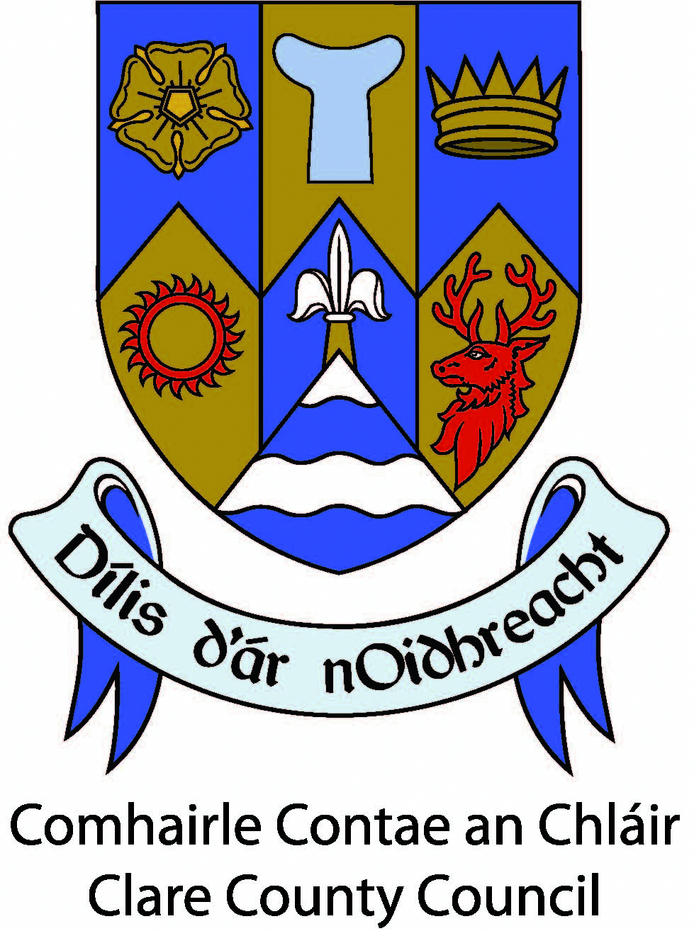
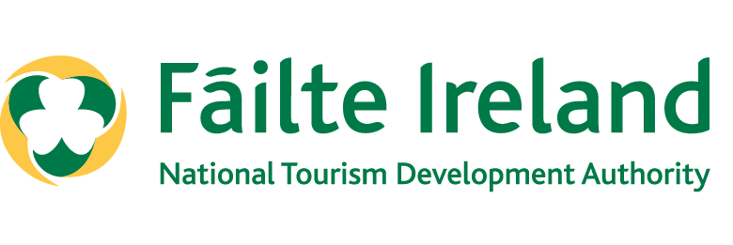
Clare County Council

Failte Ireland: Regional Festival & Participative Events Programme 2026

Guidelines for Applicants

Introduction
The Regional Festival & Participative Events Funding Support Programme 2026, County Clare.

Purpose of the Programme
The aim of this Programme is to support festivals and participative events in County Clare. The supported events must help to drive domestic and international tourism arrivals to Clare, win bed nights, stimulate local economic activity, and help to improve the visitor experience in the county.

Application forms must be completed ONLINE via the Festival and Events link to the online form provided by the Tourism Festivals and Events Department, Clare County Council.

Note: There is no guarantee of funding for applications which achieve the minimum eligibility requirements. The fund is limited, and all eligible applications will be evaluated on a competitive basis against the criteria set out.

Qualifying Conditions & Minimum Eligibility Thresholds for 2026:
The Festival or Participative Event should help to attract domestic and international visitor arrivals to County Clare. The festival/event must:

- have a minimum expenditure of €10,000.
- generate a minimum of 300 visitor bed nights in paid accommodation.
- take place during 2026.
- have an online presence on www.VisitClare.ie
- include high-quality content and design.
- have appropriate insurance cover.
- be fully compliant with current regulations and requirements for holding such an event.

Please ensure your event complies with prevailing government and public health guidelines www.gov.ie

Who can apply?
Groups, companies, and individuals who have a business address and a current Tax Clearance Access Number in the Republic of Ireland.

Eligible Festivals / Events:
To be eligible for funding, in addition to the other qualifying criteria, festivals and participative events must fit into one of the following categories:
- General Festivals (literary, historic, traditional culture or family focused).
- Arts, Music and Theatre Festivals.
- Food and Drink.
- Sports and Outdoors.
- Business and Education.

Ineligible Festival / Events:
The following festivals and events are not eligible for funding:
- Events with minimal tourism appeal. Appeal is indicated by their ability to attract visitors to Clare as a destination, rather than be something extra for visitors to experience when already in Clare.
- Purely commercial events with limited tourism appeal.
- Agricultural shows and countryside fairs with limited tourism appeal.
- Spectator-based sporting events.
- Circuses and carnivals.
- Christmas fairs, markets and parades.
- The event is being funded directly by Fáilte Ireland.

Eligible Expenses:
The following costs are eligible expenses under this fund:
- Programme content – activities and events included in the Festival & Events Programme.
- Marketing – local and national marketing and promotional activity including advertising, online marketing, and public relations costs.
- Training and Development – costs associated with training courses, festival branding, and feasibility studies.

Ineligible Expenses:
Expenses not covered by the fund include:
- The cost of items for resale.
- Unpaid expenditure.
- Fines, penalty payments, legal costs, audit fees, financial consultancy fees, insurance fees.
- Un-vouched expenditure.
Applicants must: -
Provide an outline of the eligible Festival and Participative Event.
- Outline how the event programme will help to attract in domestic and international visitors to County Clare – and provide a memorable visitor experience.
- Provide clear details of their marketing plan, anticipated income and expenditure, their waste management plan, and other information as outlined on the online application form.
- Environmental Consents: Along with including the waste management plan please ensure the festival has appropriate environmental consents in place. Please refer to Fáilte Ireland Sustainable Festival Guidelines – Section on ‘Nature & Biodiversity”: “According to the legislation, there are specific activities that will require consent if undertaken on or near a Special Area of Conservation (SAC) or Special Protection Area (SPA). SACs and SPAs are collectively termed ‘European sites’ or ‘Natura 2000 sites’. You can find a list and a map of these sites at the National Parks and Wildlife Service (NPWS) website”.
- Provide a profile of the organisational structure and the experience of the team that will deliver the proposed event. The proposed festival/event must be professionally designed and delivered.
- Commit to acknowledge Clare County Council and ‘Visit Clare’ funding support in publicity and to use both logos on promotional material. Note: Only to be credited when 2026 funding has been approved and must be removed post the event.

Visit Clare Brand
Clare County Council is committed to working in partnership with the festival/events organisers to achieve the vision as set out in the Clare Tourism Strategy 2030. In order to work collaboratively to achieve this outcome please;
- list your event annually on www.visitclare.ie This online form is available www.VisitClare.ie/web
- Use the free resources to Share Clare https://www.visitclare.ie/share

Evaluation:
Your application will be assessed only on the information submitted along with the completed online application form.

Your application will be assessed based on the following: -

- Seasonality (20%).
- Increase awareness of the area (10%).
- Increase dwell time in the local area (20%).
- Adds variety and diversity to the destination (10%).
- Animates the local Area (20%).
- Contributes towards the local economy (including night-time economy) (20%).

You are encouraged to include documentation with your application to support any information given.

An internal Evaluation Group within the Council, comprising members of the executive, will assess your application and make a recommendation.

Following this evaluation, the Elected Members will consider the Evaluation Group’s recommendation initially at the relevant Committee of Council.

Final approval of funding rests with the Elected Members of Clare County Council based on a decision at a full Council meeting.

The following will be used when assessing applications:

- Festival & Participative Events Programme: The Festival & Events Programme must include high quality content and design. This shapes the ability of the event to attract in visitors, win bed nights, stimulate local economic activity, and help to improve the visitor experience in the host area in Clare.

- Collaboration: The extent to which the festival/event collaborates with the local community and other organisations/partners/tourism networks to maximise the local and visitor potential of the festival/events.

- The Brand Fit: The synergy between the festival/event and tourism strengths of the host area, with the Visit Clare Brand, including Ennis, The Wild Atlantic Way, and Ireland’s Hidden Heartlands.

- Marketing & Digital: How the festival/event is going to be marketed to generate interest for the festival and attract visitors to Clare. We will also evaluate how the festival will be presented online and through digital marketing channels to generate tourists.

- The Environmental Management Plan: The actions the Festival/Event will take to minimise the impact on the environment (e.g. preventing waste, reduction in energy & water use, minimising/eliminating single use materials, etc). Please refer to above and to the Fáilte Ireland Sustainable Festival Guidelines

- The Delivery Team Capacity & Budget: Extent to which the festival/event demonstrates its organisational capacity to deliver the festival and the quality of the application in terms of budgeting.

Supporting Documents:
The following documents must be available on request: -
- Vision and Mission Statement.
- Child Protection Policies and Procedures.
- Health and Safety Plan.
- Copy of current Insurance cover.
- Provide evidence of more than 300 bed nights in paid accommodation within 50km of the festival/event.
Acceptance of Offer:
Following the approval of grants at the full Council meeting, the Council’s Tourism Department will formally write to the applicant informing the applicant if the application has been successful or not and will indicate the level of support on offer. The letter of offer will be accompanied by a Funding Agreement setting out the terms and conditions of the offer. The Funding Agreement must be signed by the relevant persons and a signed copy must be returned to the Tourism Department of Clare County Council within 10 days of receipt of the letter of offer. Offers will lapse in the absence of the return of a signed Funding Agreement.

How do I draw down the grant?
Once the festival / event has been completed, successful applicants can submit a claim.

The Successful Applicants will be required to:

- Complete and submit a comprehensive post-event report. This is a short summary report on the funded festival/event. The report must be accompanied by:
- Invoices and original receipts detailing expenditure – Invoices and receipts must reference the name of the Grantee e.g name of the Group, dated 2026.
- Submit photographic evidence.
- Comply with Tax Clearance procedures.
Funding drawdown to be submitted no later than Friday, 4th December 2026.

Funding is allocated on an annual basis and cannot be carried forward. Funding not claimed by the agreed deadline will be withdrawn.

Online applications can be made from Friday, 9th January 2026.

The Closing Date for submission of online applications is 4pm, on Friday, 30th January 2026.

Please ensure that your current financial details (i.e. Bank Account number, Treasurer’s name, address and contact details etc) are up to date and notified to our Accounts Payable Team, Finance Directorate. A Supplier Setup / Amendment Form may need to be completed.

Contact:
Clare County Council,
Tourism, Festivals and Events Department,
New Road,
Ennis, Clare.

Phone: (065) 6846493

Email: tourism@clarecoco.ie
